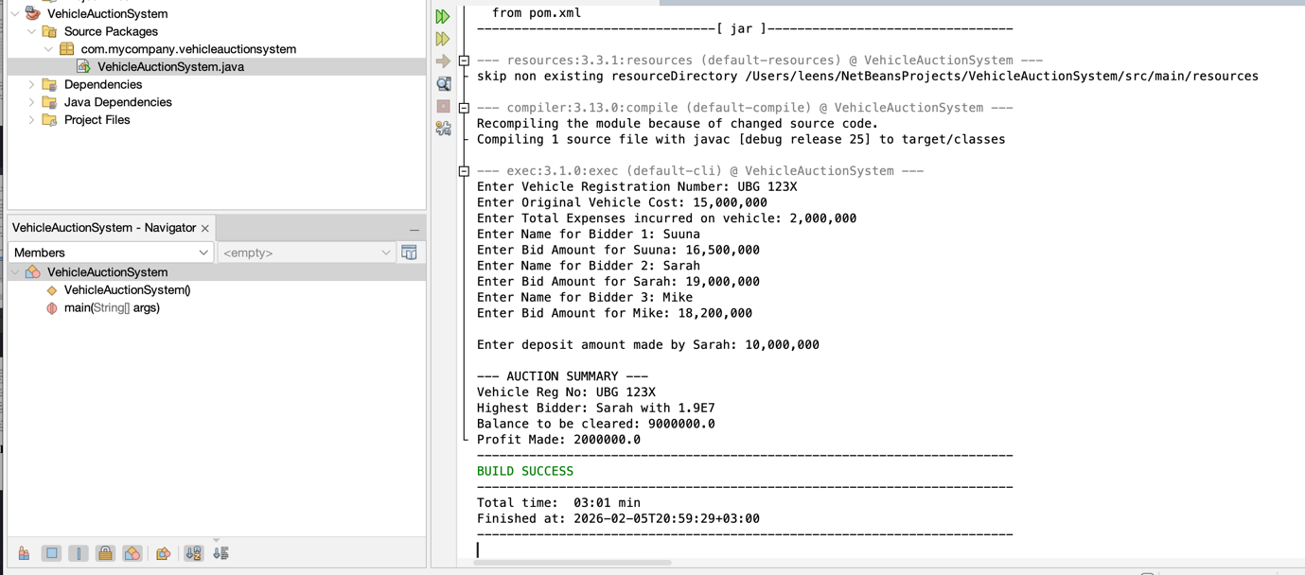
Figure 1 Entering bidder data
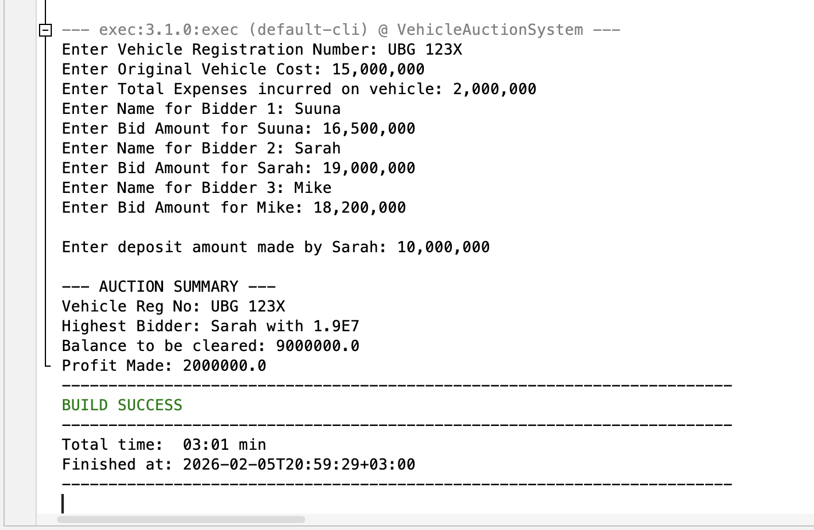
Figure 2 Displaying the best bidder

